A screenshot of a cell phone

Description generated with very high confidence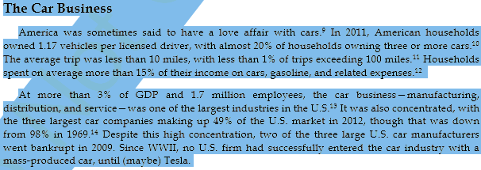A screenshot of text

Description generated with very high confidenceA screenshot of a cell phone

Description generated with high confidenceA screenshot of a cell phone

Description generated with very high confidenceA screenshot of a cell phone

Description generated with high confidenceA screenshot of a cell phone

Description generated with high confidenceA screenshot of a cell phone

Description generated with very high confidenceA close up of a newspaper

Description generated with high confidenceA screenshot of a cell phone

Description generated with high confidenceA screenshot of a cell phone

Description generated with high confidenceA screenshot of a cell phone

Description generated with very high confidenceA screenshot of a social media post

Description generated with very high confidenceA picture containing text, newspaper

Description generated with very high confidenceA screenshot of a cell phone

Description generated with very high confidenceA screenshot of a social media post

Description generated with very high confidence